1. **Watch the terraform-02 video.**
2. **Execute all the templates shown in video.**

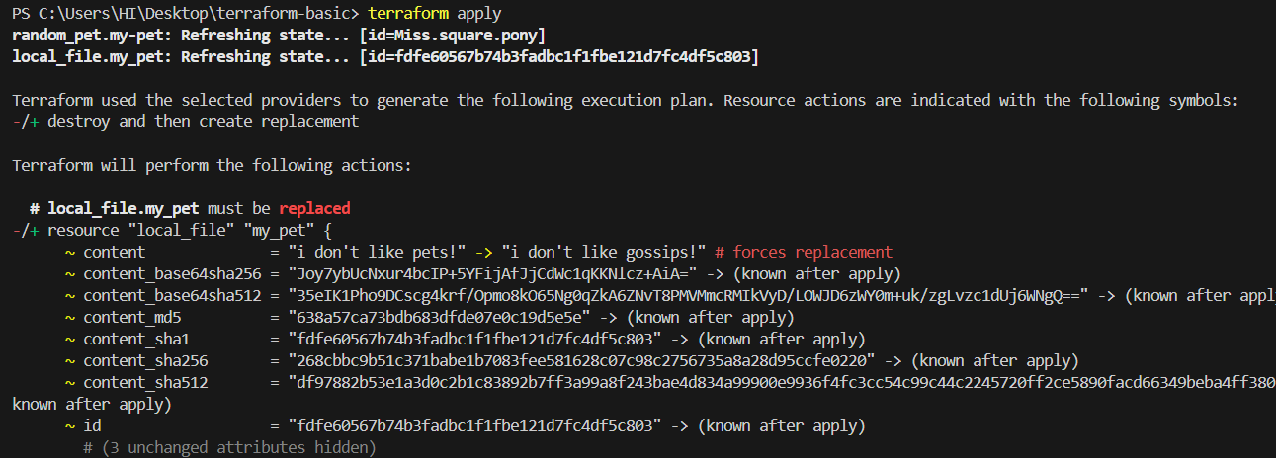

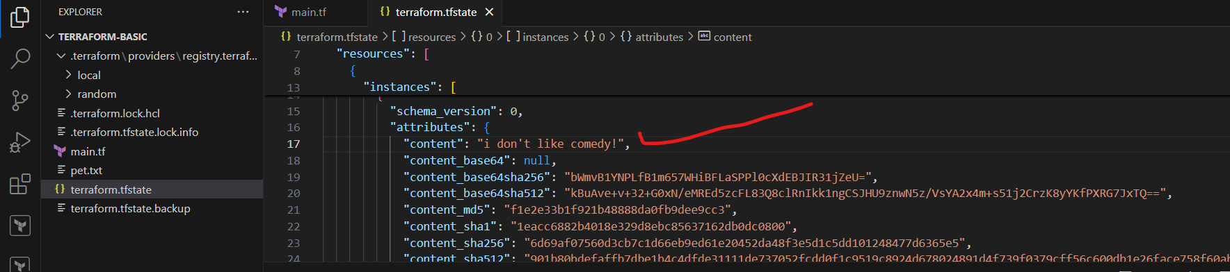

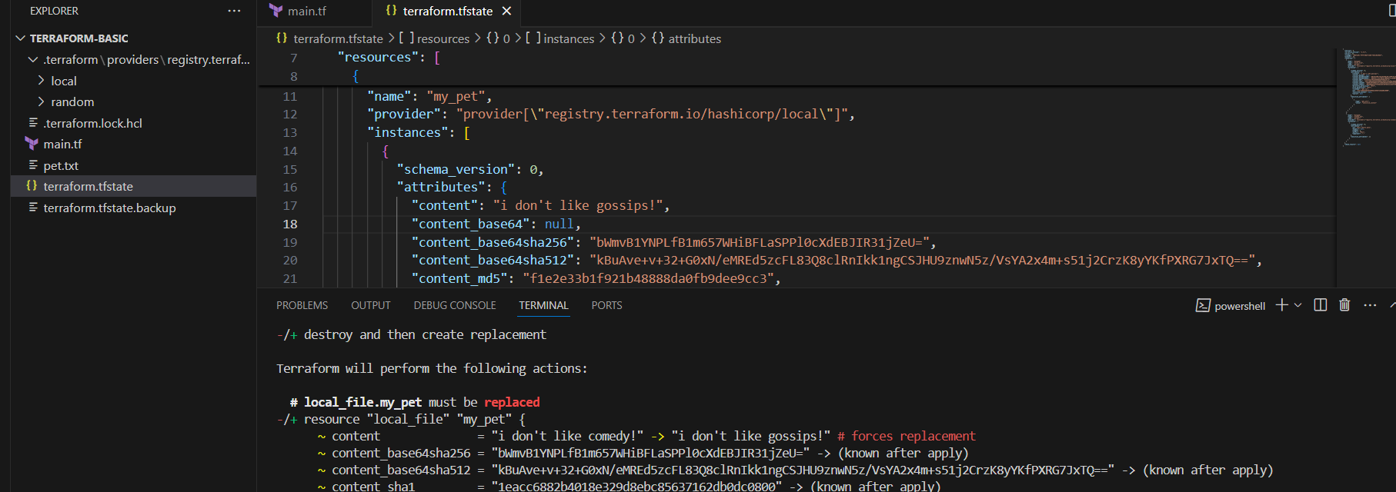

resource "local_file" "my_pet" {

    filename = "pet.txt"

    content = "i like nature !"

    lifecycle {

      create_before_destroy = true

    }

}

resource "random_pet" "my-pet" {

  prefix = "Miss"

 separator = "."

 length = "2"

}

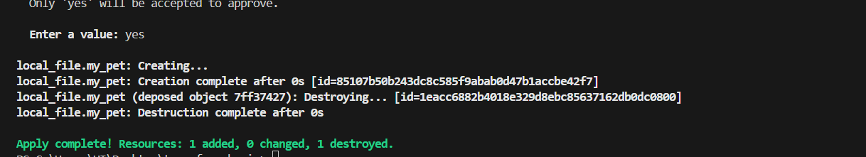

resource "local_file" "my_pet" {

    filename = "pet.txt"

    content = "i like sweets !"

    lifecycle {

      prevent_destroy = true

    }

}

resource "random_pet" "my-pet" {

  prefix = "Miss"

 separator = "."

 length = "2"

}

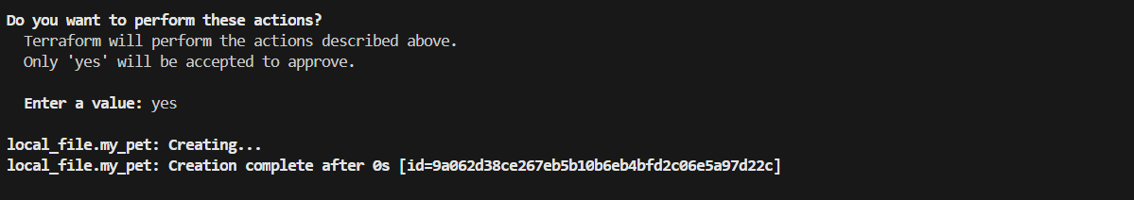

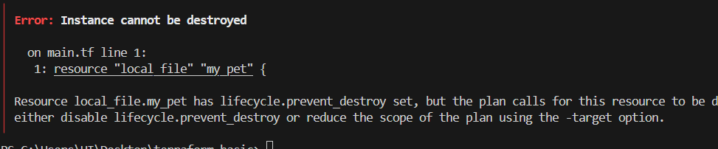

resource "local_file" "my_pet" {

    filename = "pet.txt"

    content = "i walk everyday!"

    lifecycle {

      ignore_changes = [

        all

       ]

    }

}

resource "random_pet" "my-pet" {

  prefix = "Miss"

 separator = "."

 length = "2"

}

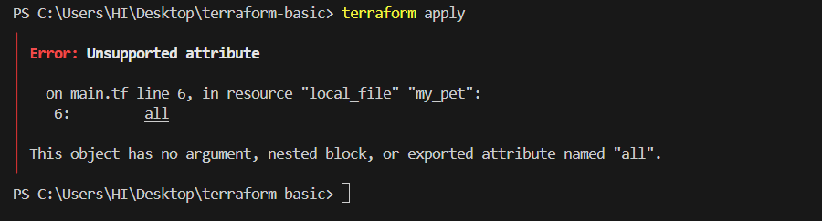

    content = "i walk everyday!"

    lifecycle {

      ignore_changes = [

        content

       ]

    }

}

resource "random_pet" "my-pet" {

  prefix = "Miss"

 separator = "."

 length = "2"

}

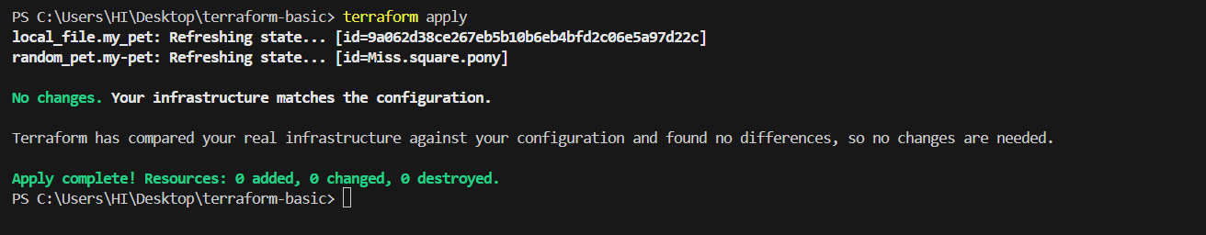

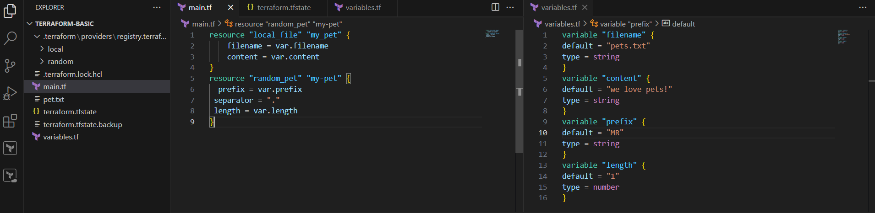

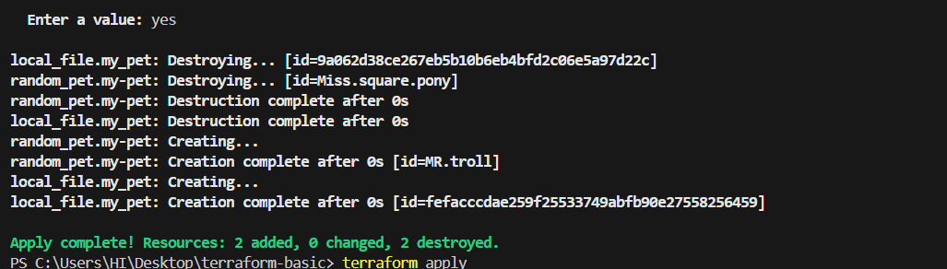

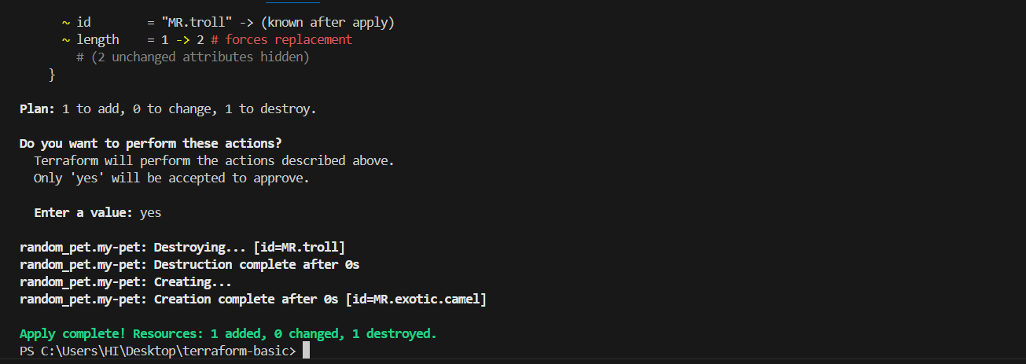

**3) Integrate terraform in jenkins using Terraform plugin.**